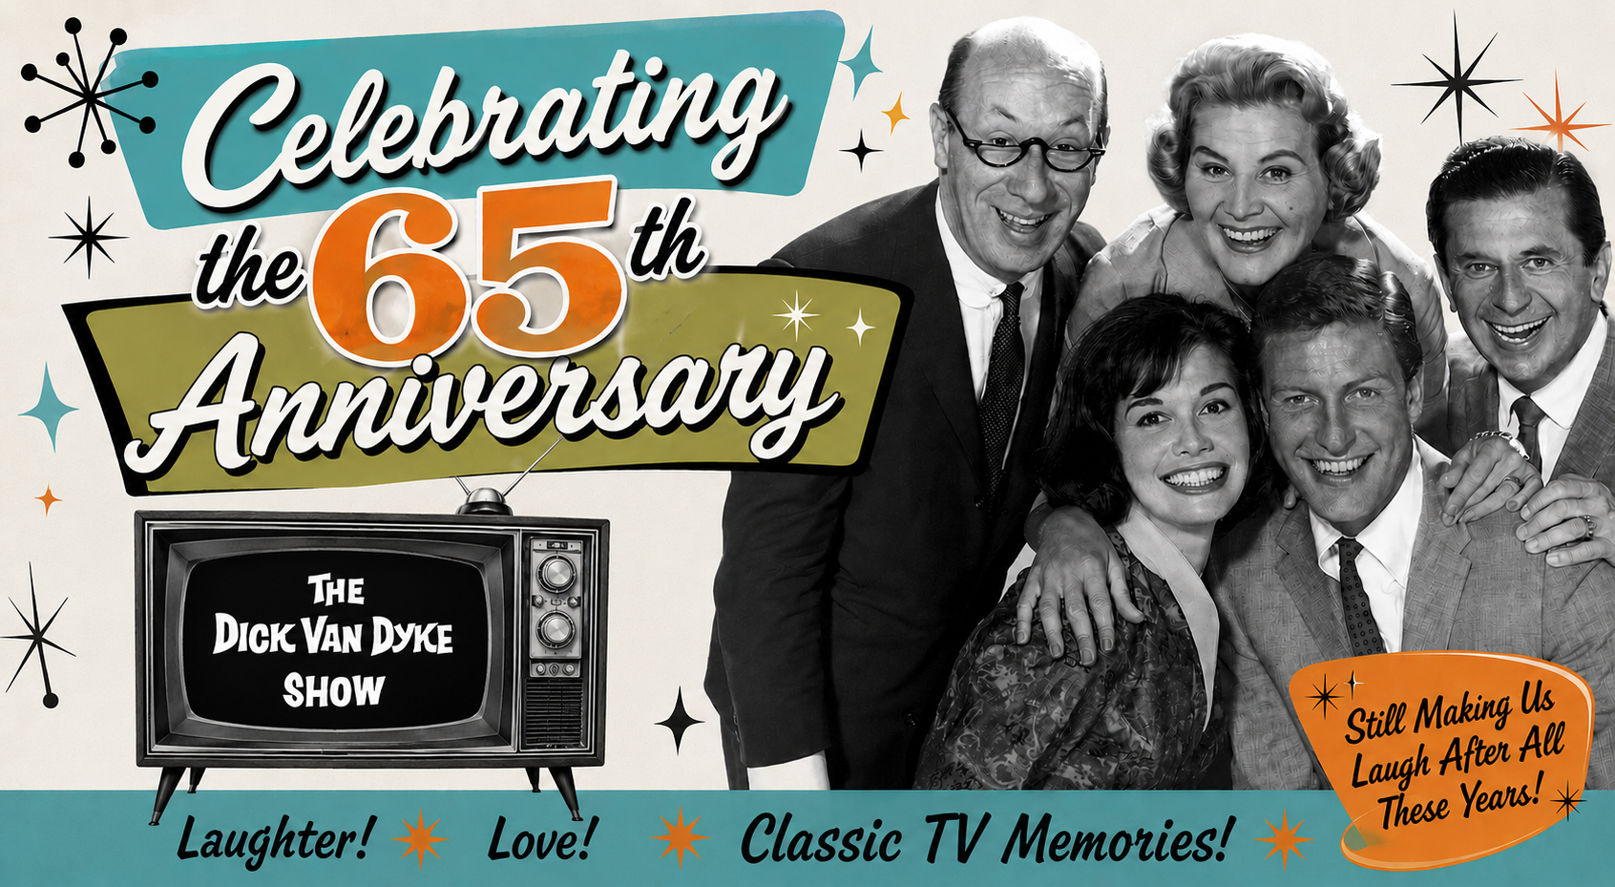
David Van Deusen Bio

Author of From Fandom to Friendships: My Adventures with
The Dick Van Dyke Show Cast

David Van Deusen is a longtime historian, archivist, author, and leading authority on The Dick Van Dyke Show. His journey began as a devoted fan in 1995, when he launched The Walnut Times, a fan newsletter. Over the next 20 years, the publication evolved into a respected resource for fans and a foundation for his extensive research and archival work. Van Deusen published 62 issues, first in print and later digitally, reaching subscribers across the United States and internationally. Through that work, he developed close personal relationships with members of the cast, earning their trust and support—Dick Van Dyke affectionately dubbing him “The Head Walnut” and Carl Reiner referring to him as “the other DVD.”

Van Deusen’s expertise and archives have led to contributions to numerous television and archival projects, including A&E Biography, E! Entertainment and TV Land programs about Dick Van Dyke, and DVD and Blu-ray releases of The Dick Van Dyke Show. He assisted Carl Reiner with research and archival footage for The Dick Van Dyke Show Revisited, earning a credit on the 2004 CBS reunion special.

Van Deusen is the author of To Twilo and Beyond! My Walnut Adventures with “The Dick Van Dyke Show” Cast (2005) and his current book, From Fandom to Friendships: My Adventures with the Dick Van Dyke Show Cast. He also produced the acclaimed The Dick Van Dyke Show 60th Anniversary Celebration, now being updated and rereleased for the show’s 65th anniversary. Featuring interviews with cast members and their families, writers, producers, directors, musicians, and other members of the creative team, the documentary offers an unprecedented oral history of the beloved series.

Van Deusen co-hosts Tripping Over the Ottoman, the only podcast devoted exclusively to The Dick Van Dyke Show, and recently served as a Creative Consultant on PBS’s American Masters documentary Starring Dick Van Dyke. In September 2025, he produced a Dick Van Dyke Show fan event in New Rochelle, New York, with Larry Mathews, who played Ritchie Petrie, and he moderates a Facebook group called Celebrating The Dick Van Dyke Show with nearly 23,000 members.

Born in 1960 in Albany, New York, Van Deusen developed an early interest in the performing arts and performed with several musical groups, singing and playing guitar, banjo, bass, and piano. In 1983, he earned a bachelor’s degree in Business from The College of St. Rose in Albany and began a nearly 37-year career with New York State government, retiring as an IT professional in 2020.

Married with three grown children, Van Deusen continues his role as the keeper of the legacy of The Dick Van Dyke Show, preserving the history, stories, and memories of the people who brought the series to life. Carl Reiner described him as its “voluntary historian and archaeologist,” writing that “all of us connected with the show could not be more pleased that he took on this task.”

Press kit documents are available here, Images here and Videos, here.

Contact:
Randi Cone
Randi@rconemedia.com
917-744-1528

