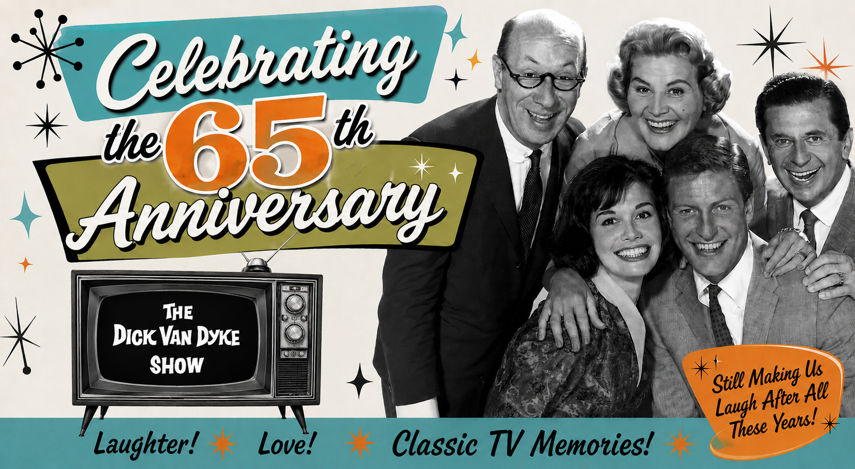
The Dick Van Dyke Show
Fact Sheet

The Dick Van Dyke Show was a pioneering American television sitcom that aired on CBS from October 3, 1961, to June 1, 1966, spanning 5 seasons and 158 episodes. Created and produced by Carl Reiner, the series famously chronicled the work life and home life of television comedy writer Rob Petrie. Widely considered one of the greatest sitcoms in television history, the show was renowned for its sharp writing, physical comedy, and charismatic ensemble cast.

Overview & Core Production

Creator: Carl Reiner
Network: CBS
Production Company: Calvada Productions
Primary Directors: John Rich, Jerry Paris, Sheldon Leonard
Premise: The daily trials of Rob Petrie, head writer for the fictional variety program The Alan Brady Show, and his life in New Rochelle, New York, with his wife, Laura, and son, Ritchie.

Principal Cast & Characters

Rob Petrie (Dick Van Dyke): Head comedy writer.
Laura Petrie (Mary Tyler Moore): Rob’s wife, a former dancer.
Buddy Sorrell (Morey Amsterdam): Wisecracking co-writer.
Sally Rogers (Rose Marie): Bold, husband-hunting co-writer.
Mel Cooley (Richard Deacon): The bald, balance-sheet-driven producer.
Ritchie Petrie (Larry Matthews): Rob and Laura's young son.
Alan Brady (Carl Reiner): The demanding, egotistical star of the show-within-a-show.
Millie Helper (Ann Morgan Guilbert): Laura’s neighbor and best friend.
Jerry Helper (Jerry Paris): Rob’s friend and dentist.

Primetime Emmy Awards and Honors

Over is five-year run, the show secured 25 Emmy nominations and won 15 times.

Major Emmy Wins include:

Outstanding Comedy Series: Won 4 times (1963, 1964, 1965, 1966).

Outstanding Lead Actor in a Comedy Series: Dick Van Dyke won 3 consecutive times (1964, 1965, 1966).

Outstanding Lead Actress in a Comedy Series: Mary Tyler Moore won 2 times (1964, 1966).

Outstanding Writing Achievement in Comedy: Carl Reiner, Sam Denoff, and Bill Persky won multiple awards across different seasons.

Outstanding Directorial Achievement in Comedy: Jerry Paris won in 1964.

Other Notable Major Honors

Writers Guild of America (WGA) Awards: The show earned 10 nominations and multiple wins for outstanding comedy writing.

TV Land Awards: In 2003, the show received the TV Land Legend Award, celebrating its enduring impact on pop culture.

Industry Legacy:

The series is preserved in the Museum of Broadcast Communications and frequently ranks in the top tier of TV Guide’s "Greatest TV Shows of All Time."

Two iconic episodes of The Dick Van Dyke Show ranked in TV Guide's 1997 landmark list of the "100 Greatest Episodes of All Time.”

"Coast-to-Coast Big Mouth" (Season 5, Episode 1) – Ranked #8. In this legendary episode, Laura accidentally reveals on a national television game show that Rob's tyrannical boss, Alan Brady, is bald!

"It May Look Like a Walnut" (Season 2, Episode 20) – Ranked #15. After watching a late-night sci-fi movie, Rob experiences a surreal nightmare where his loved ones lose their thumbs and imaginations. He panics as the world is taken over by an alien named Kolak
and an overwhelming mountain of walnuts.

Press kit documents are available here, Images here and Videos, here.

Contact for David Van Deusen:
Randi Cone
randi@rconemedia.com
917-744-1528

