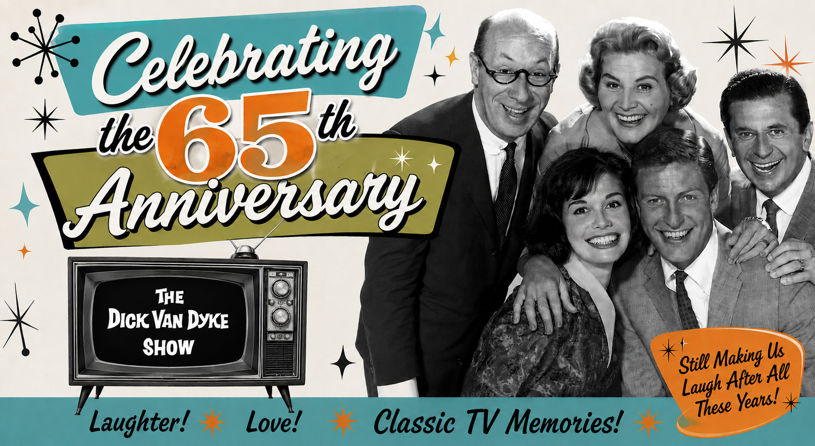
BOOK FACT SHEET
FROM FANDOM TO FRIENDSHIPS
My Adventures with the Dick Van Dyke Show Cast

Author: David Van Deusen
Publication Date: September 29, 2026
Occasion: 65th Anniversary of The Dick Van Dyke Show
Format: Digital PDF
Pages: 185
Price: $15.99
Available: Preorder available September 1, 2026
Website: payhip.com/theotherdvd
Press kit documents are available here, Images, here and Videos, here.

LOGLINE
The extraordinary 30-year journey of a devoted fan whose passion for The Dick Van Dyke Show led to lasting friendships with its cast and creators and a mission to preserve the show's legacy.

ABOUT THE BOOK
His lifelong love for The Dick Van Dyke Show led David Van Deusen on an extraordinary journey that grew into friendships with the show's stars, creators, writers, crew members, and their families. Along the way, he became dedicated to preserving the show's legacy, earning recognition from Carl Reiner as its “archivist.”
In From Fandom to Friendships: My Adventures with the Dick Van Dyke Show Cast, Van Deusen shares more than three decades of personal reminiscences, including unforgettable personal encounters with Carl Reiner, Dick Van Dyke and Rose Marie; cast performances, appearances and reunions; memorabilia and artifacts from his collection; and the many lasting friendships that developed along the way. Unlike a traditional memoir, the book is also an interactive experience, featuring exclusive audio recordings, rare video, archival photographs, and other multimedia accessed through embedded links and QR codes.

FROM THE BOOK
“Over the years, I have given an abundance of DVD info and shared many personal artifacts and stories, all the while knowing that David was thrilled to hear, and knowing he would bring all that to the fans that so deserve these insights about our show. I trust him like my own family. So as you enjoy this new book, know that it comes as a labor of love, and shows you how special of a man David is! And now we can truly consider him the ‘official’ historian of The Dick Van Dyke Show.”
— Larry Mathews, who played Ritchie Petrie, Foreword, August 2026

“Among the very few exceptions of maintaining distance from the work of my father has been my relationship with David Van Deusen. Over the years I have assisted David with information, videos, and other inquiries in his quest to make his documentary Celebrating The Dick Van Dyke Show the ‘go to’ source for fans and all of those who love and remember the show. I have not engaged with anyone else in similar efforts simply because David’s motivations and the quality of his work are truly special.”
— Chris Van Dyke, son of Dick Van Dyke, Foreword, July 2026

“If there was a game show, and the category was The Dick Van Dyke Show, David would break the bank. There is not a moment he can’t remember and bring to life. I want to take this opportunity, yet another time, to thank David for keeping the show alive and well.”
— Bill Persky, Emmy Award-winning writer/producer of The Dick Van Dyke Show, Afterword, Spring 2026

CONTENTS
Foreword — Larry Mathews
Foreword — Chris Van Dyke
Preface
Acknowledgements
Chapter 1 — A Visit to Danville
Chapter 2 — Dick Van Dyke Returns to Broadway
Chapter 3 — TDVDS Riches
Chapter 4 — Legendary Ladies of Stage and Screen
Chapter 5 — A Presidential Connection?
Chapter 6 — NACKVID KEYD
Chapter 7 — Dick's Lucky Life
Chapter 8 — On the Walk of Fame with Rose Marie
Chapter 9 — The 50th Anniversary
Chapter 10 — Play It Again, Irma!
Chapter 11 — Plucking Feathers and the Carl Reiner Money Clip
Chapter 12 — A Calvada Production
Chapter 13 — The Mountain Palace with Pickles
Chapter 14 — H. Fieldstone Thorley
Chapter 15 — “The Dick Van Dyke Show…Starring Dick Van Dyke…”
Chapter 16 — Guest Star Memories
Chapter 17 — The Walnut Times Bids Farewell
Chapter 18 — Wait for Your Laugh
Chapter 19 — Celebrating the 60th Anniversary
Chapter 20 — The Carl Reiner Department of Archives and Preservation
Chapter 21 — Tripping Over the Ottoman
Chapter 22 — 148 Bonnie Meadow Road
Chapter 23 — Remembering MTM
Chapter 24 — Larry Mathews Day in New Rochelle
Chapter 25 — Dick Van Dyke Turns 100!
Chapter 26 — The Dick Van Dyke Show Legacy — 65 Years and Still Going Strong
Afterword — Bill Persky
Also Includes:
Memorabilia and Artifacts
TDVDS Fun: Name the Episode! and Name the Episode Answers

####

For more information, contact:
Randi Cone
Cone Media And Associates
randi@rconemedia.com
917-744-1528

